Lecture#7 Image
Objectives
- Image
  - Asset
  - Camera
  - Gallery

Picking Image from Assets:
Step1:
- Create a folder with name assets
- Add a subfolder in assets with name images
- Add images in images folder
Step 2:
Make following changes in assets section of pubspec.yaml file
assets:
- assets/images/
Step 3:
Now for Accessing image from assets, we will use Image.asset constructor of
Image.asset("assets/images/img1.png",
height: 100,
width: 100,)
Will display image having height and width 100. Note that image1.png must be in images folder inside assets:
Image.asset contains fit property code given below fit is assigned a value BoxFit.fill that will fill the entire image inside the parent of image that is container in below code.
Container( height: 100,
width: 100,
child: Image.asset('assets/Images/img1.png',
fit: BoxFit.fill,)
BoxFit Values
Box Fit Values | Output
fill: Fill the target box by distorting the  source ratio | 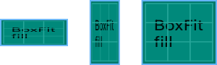
contain: As large as possible while still containing the source entirely within the target box. | 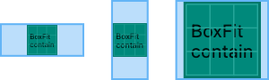
cover: As small as possible while still covering the entire target box. | 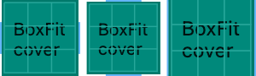
fitWidth: Make sure the full width of the source is shown, regardless of whether this means the source overflows the target box vertically. | 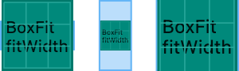
fitHeight: Make sure the full height of the source is shown, regardless of whether this means the source overflows the target box horizontally. | 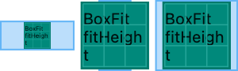
none: Align the source within the target box (by default, centering) and discard any portions of the source that lie outside the box. | 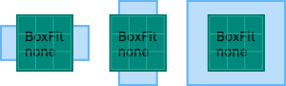
scaleDown: Align the source within the target box (by default, centering) and, if necessary, scale the source down to ensure that the source fits within the box. This is the same as contain if that would shrink the image, otherwise it is the same as none. | 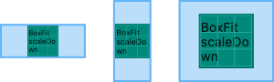
Example:
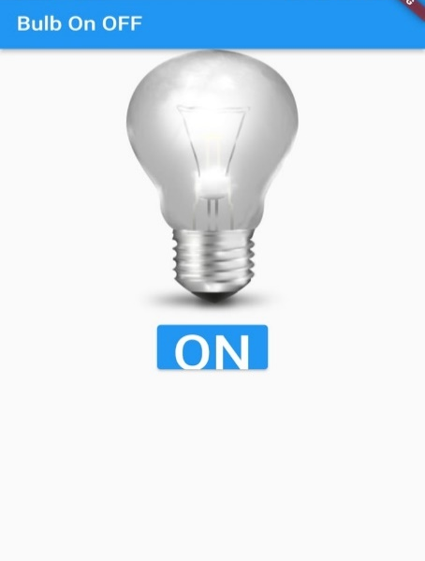 | 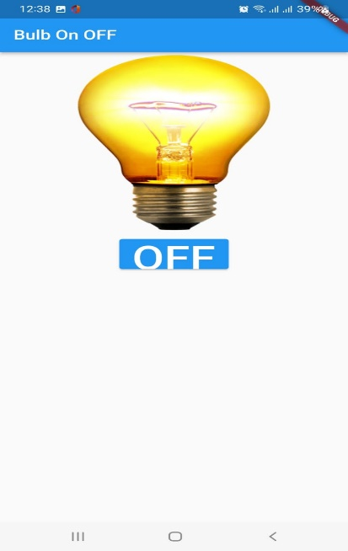 | In assets we have two images on.png and off.png. Initially off.png will be displayed with button having ON text. On clicking button image on.png is displayed and text of button is changed from on to off. and vice versa
Code:
import 'package:flutter/material.dart';

void main() {
runApp(MaterialApp(home: BulbOnOffScreen(),));
}

class BulbOnOffScreen extends StatefulWidget {
@override
State<BulbOnOffScreen> createState() => _BulbOnOffScreenState();
}
class _BulbOnOffScreenState extends State<BulbOnOffScreen> {
bool isOn=false;
void changeState()
{
setState(() {
isOn=!isOn;
});
}
@override
Widget build(BuildContext context) {
return Scaffold(
appBar: AppBar(title: const Text("Bulb On OFF ")),
body: Center(
child: Column(children: [
Container(
height: 300,width: 300,
child: Image.asset(isOn?"assets/images/on.png":"assets/images/off.png",
fit: BoxFit.fill,
),
),
const SizedBox(height: 10,),
Container(
height: 50,
child: ElevatedButton(
onPressed:changeState, child: Text(isOn?"OFF":"ON",style: TextStyle(fontSize: 50),)),
)
]),
),
);
}
}
Picking Image from camera and Gallery
From flutter pub.dev add dependency for image picket in pubspec.yaml
dependencies:
image_picker: ^0.8.6
using Image picker dependency we pick image and videos from gallery or camera. Import dart package 'package:image_picker/image_picker.dart' for using ImagePicker class. Sample Code for picking images
final ImagePicker _picker = ImagePicker();
// Pick an image from gallery
final XFile? Image = await _picker.pickImage(source: ImageSource.gallery);
// Capture a photo from camera
final XFile? photo = await _picker.pickImage(source: ImageSource.camera);
// Pick multiple images
final List<XFile>? images = await _picker.pickMultiImage();
Now let us consider an app that will pick image from gallery or camera and display in image.
Image.file( File file)
Image.File constructor requires a mandatory argument file for displaying image.
Consider given function for picking image from camera
void pickImagefromCamera( ) async{
final XFile? photo = await _picker.pickImage(source: ImageSource.camera);
File f=File(photo!.path);
Image.File(f);
}
Note: pickImage method returns Future<XFile?>. Use await key word is used before method returning Future and method in which await is used must be async

Consider an app where an image is displayed from an asset if a user clicks camera button camera opens and image clicked will be displayed. If gallery button is clicked image picked from gallery is displayed. | 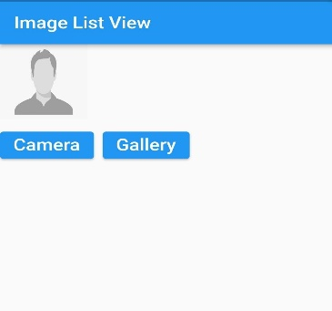
Code:
import 'package:flutter/material.dart';
import 'package:flutter/src/foundation/key.dart';
import 'package:flutter/src/widgets/framework.dart';
import 'package:image_picker/image_picker.dart';
class MySimpleImagePicker extends StatefulWidget {
@override
State<MySimpleImagePicker> createState() => _MySimpleImagePickerState();
}
class _MySimpleImagePickerState extends State<MySimpleImagePicker> {
File? img;
Container getImage(){
if(img==null){
return Container(
height: 100,
width: 100,
child: Image.asset('assets/Images/profile.png',
fit: BoxFit.fill,
),
);
}
else{
return Container(
height: 100,
width: 100,
child: Image.file(img!,
fit: BoxFit.fill,
),
);
}
}
@override
Widget build(BuildContext context) {
return Scaffold(
appBar: AppBar(title: Text("Image Picker"),),
body: Column(
mainAxisAlignment: MainAxisAlignment.start,
crossAxisAlignment: CrossAxisAlignment.start,
children:[
getImage(),
SizedBox(height: 10,),
Row(
children: [
ElevatedButton(onPressed: ()async{
XFile? selectedimg;
ImagePicker picker=ImagePicker();
selectedimg =await picker.pickImage(
source:ImageSource.camera);
if(selectedimg!=null)
{
setState(() {
img=File(selectedimg!.path);
});
}
}, child:Text('Camera',style:TextStyle(fontSize: 20)
)
),
SizedBox(width: 10,),
ElevatedButton(onPressed: ()async{
XFile? selectedimg;
ImagePicker picker=ImagePicker();
selectedimg =await picker.pickImage(
source: ImageSource.gallery);
if(selectedimg!=null)
{
setState(() {
img=File(selectedimg!.path);
});
}
}, child:Text('Gallery',style:TextStyle(fontSize: 20)
)
),
]
)
]
),
);
}
}

Lecture#8 List View
Objectives
- List View
- List Tile
- List View Builder
- Images in a list view
List View:
List View is a scrollable list. It displays its children one after another in the scroll direction i.e., vertical or horizontal.
Constructor of List View
ListView({Key key, Axis scrollDirection: Axis.vertical,
bool reverse: false, ScrollController controller,
bool primary,
ScrollPhysics physics,
bool shrinkWrap: false,
EdgeInsetsGeometry padding,
double itemExtent,
bool addAutomaticKeepAlives: true,
bool addRepaintBoundaries: true,
bool addSemanticIndexes: true,
double cacheExtent,
List<Widget> children: const <Widget>[],
int semanticChildCount,
DragStartBehavior dragStartBehavior: DragStartBehavior.start,
ScrollViewKeyboardDismissBehavior keyboardDismissBehavior: ScrollViewKeyboardDismissBehavior.manual,
String restorationId,
Clip clipBehavior: Clip.hardEdge})
ListView attributes:
children: attribute receives list of widgets like Row and Column widget. scrollDirection: This property takes in Axis enum as the object to decide the direction of the scroll on the ListView default value is Axis.vertical if a list view is to arrange its items in horizontal than value of scolldirection will be assigned horizontal as scrolldirection: Axis.horizontal.
shrinkWrap: This property takes in a boolean value as the object to decide whether the size of the scrollable area will be determined by the contents inside the ListView.
Consider given app where a list of fruit is displayed using list view
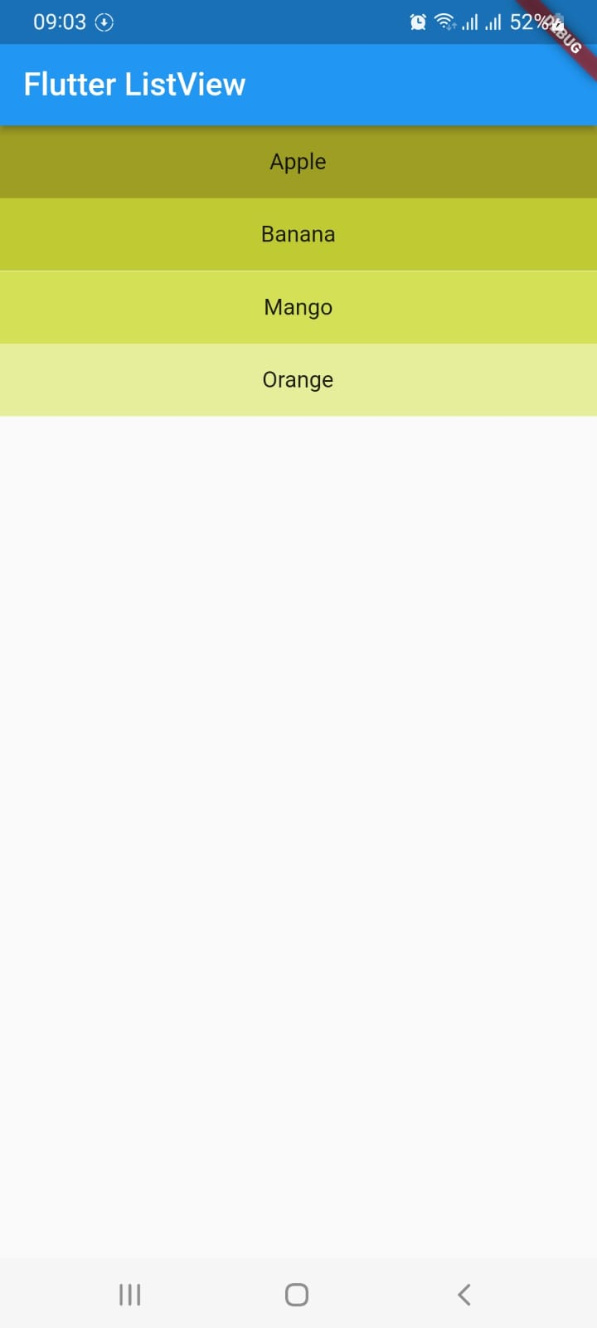
Code:
import 'package:flutter/material.dart';
void main()=> runApp(MyApp());
class MyApp extends StatelessWidget {
@override
Widget build(BuildContext context) {
return MaterialApp(
home: Scaffold(
appBar: AppBar(
title: Text('Flutter ListView'),
),
body: ListView(
children: <Widget>[
Container(
height: 50,
color: Colors.lime[800],
child: const Center(child: Text('Apple')),
),
Container(
height: 50,
color: Colors.lime[600],
child: const Center(child: Text('Banana')),
),
Container(
height: 50,
color: Colors.lime[400],
child: const Center(child: Text('Mango')),
),
Container(
height: 50,
color: Colors.lime[200],
child: const Center(child: Text('Orange')),
),
],
),
),
);
}
}

ListView.builder()
The builder() constructor constructs a repeating list of widgets. The constructor takes two main parameters:
- An itemCount for the number of repetitions for the widget to be constructed (not compulsory).
- An itemBuilder for constructing the widget which will be generated ‘itemCount‘ times (compulsory).
If the itemCount is not specified, infinite widgets will be constructed by default
ListView.builder(
itemCount: 20,
itemBuilder: (context, position) {
return Card(
child: Padding(
padding: const EdgeInsets.all(20.0),
child: Text(
position.toString(),
style: TextStyle(fontSize: 22.0),
),
),
);
},
),
Consider a given GUI
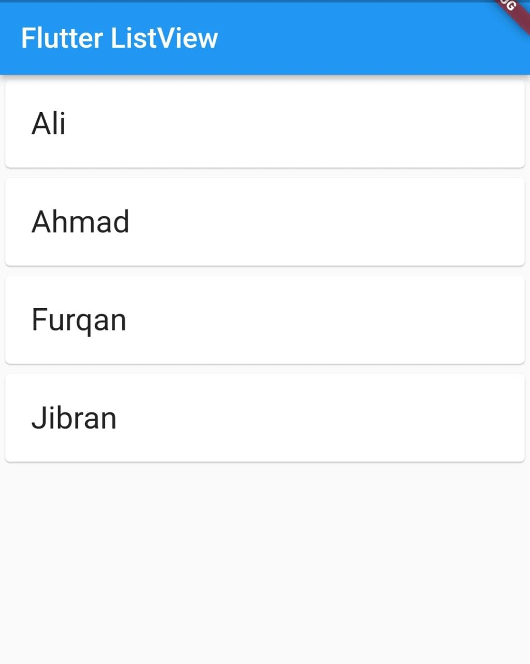 | - Create a list of string containing names  - Using list view builder display names from list as shown in app
Code:
import 'package:flutter/material.dart';
void main()=> runApp(MyApp());
class MyApp extends StatelessWidget {
List<String> names=['Ali','Ahmad','Furqan','Jibran'];
@override
Widget build(BuildContext context) {
return MaterialApp(
title: 'Flutter Demo',
theme: ThemeData(
primarySwatch: Colors.blue,
),
home: Scaffold(
appBar: AppBar(
title: Text('Flutter ListView'),
),
body: ListView.builder(
itemCount: names.length,
itemBuilder: (context,index){

String name=names[index];
return Card(
child: Padding(
padding: const EdgeInsets.all(20.0),
child: Text(
name,
style: TextStyle(fontSize: 22.0),
),
),
);

}

)
),
);
}
}

List Tile:
The ListTile widget in Flutter is a UI element that displays related information. It follows the List specification from Material Design. A typical ListTile is divided into three sections; Start, Center, and End. The Start section contains the leading widget; the Center section includes the title and subtitle, and the End section contains the trailing widget.
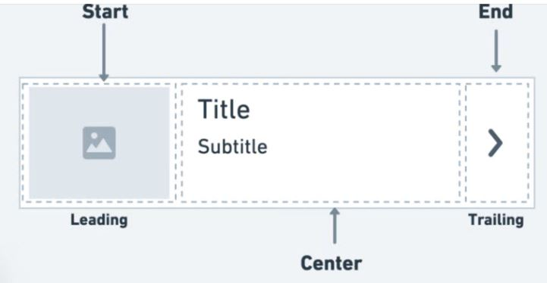
It is mainly used to populate the scrollable views such as ListView, Column, and Row. For example, you can use the ListTile to show a list of to-do items, emails, navigation options, and more. You can also receive the click event by tapping the ListTile.
Here is the minimal code to display ListTile inside the ListView widget:
ListView(
children: const [
ListTile(
leading: Icon(Icons.car_rental),
title: Text('Car'),
trailing: Icon(Icons.more_vert),
),
ListTile(
leading: Icon(Icons.flight),
title: Text('Flight'),
trailing: Icon(Icons.more_vert),
),
ListTile(
leading: Icon(Icons.train),
title: Text('Train'),
trailing: Icon(Icons.more_vert),
)
],
)

Here’s how the code is translated into the design:
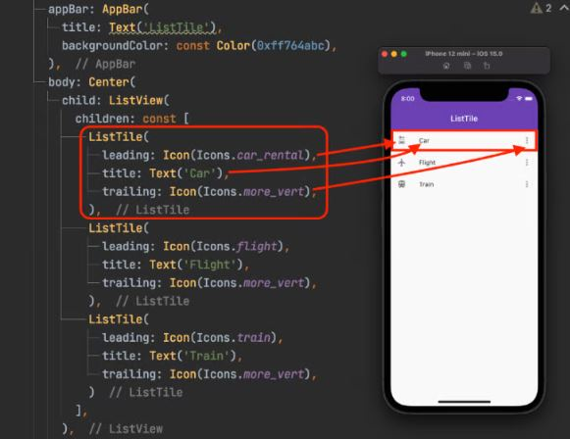
Example:
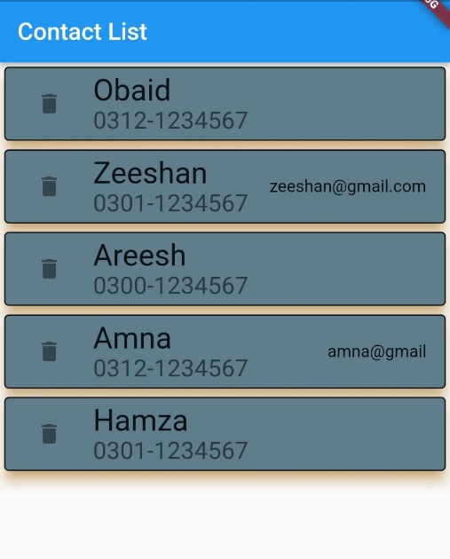 | - Create a model class having attributes name, contact number and email.  - Default value for email is null  - Create a list of model class with some dummy data  - Using model list create a view as shown in app using list view builder  - On clicking delete icon record is deleted from list and updated

Model Class:
class Contact
{
String name;
String contact;
String ?email;
Contact({required this.name,
required this.contact,this.email});
}

mylistviewbuilder.dart
import 'package:flutter/material.dart';
import 'package:flutter/src/foundation/key.dart';
import 'package:flutter/src/widgets/framework.dart';
import 'package:wk_5_sect_2_listview_listviewbuilder_card_image/Model/contactmodel.dart';

class MyListViewBuilder extends StatefulWidget {
const MyListViewBuilder({Key? key}) : super(key: key);

@override
State<MyListViewBuilder> createState() => _MyListViewBuilderState();
}

class _MyListViewBuilderState extends State<MyListViewBuilder> {
List<Contact> clist=[];
void initState(){
Contact c=Contact(name:'Obaid',contact: '0312-1234567' );
clist.add(c);
c=Contact(name:'Zeeshan',contact: '0301-1234567',email:'zeeshan@gmail.com');
clist.add(c);
c=Contact(name: 'Areesh',contact: '0300-1234567');
clist.add(c);
c=Contact(name:'Amna',contact: '0312-1234567',email: 'amna@gmail' );
clist.add(c);
c=Contact(name:'Hamza',contact: '0301-1234567');
clist.add(c);

}

@override
Widget build(BuildContext context) {
return Scaffold(
appBar: AppBar(title: Text('Contact List'),),
body:ListView.builder(
itemCount: clist.length,
itemBuilder: (BuildContext cont,int index){
Contact c=clist[index];
return Card(
elevation: 10,
shadowColor: Colors.orange,
color: Colors.blueGrey,
//surfaceTintColor: Colors.white,
child: ListTile(
leading: IconButton(icon:Icon(Icons.delete),
onPressed: (){
setState(() {
clist.removeAt(index);
});

},),
shape: OutlineInputBorder(),
title: Text(c.name,style: TextStyle(fontSize: 25),),
subtitle: Text(c.contact,style:TextStyle(fontSize: 20),),
trailing:Text(c.email==null?"":c.email!),
),
);

},
) ,

);

}
}
main.dart
import 'package:flutter/material.dart';
void main() {
runApp(MaterialApp(home: MyListViewBuilder(),));
}
Example:
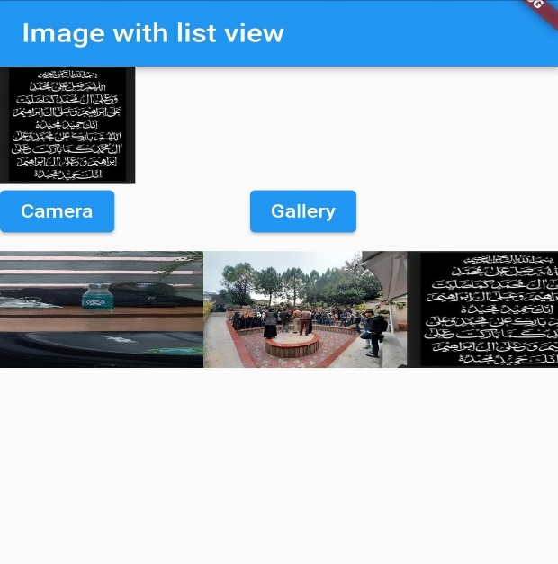 | In this app image is picked either from camera or gallery and displayed in horizontal list view.
myimagelistview.dart
import 'dart:io';
import 'package:flutter/material.dart';
import 'package:image_picker/image_picker.dart';
class MyImageWithListView extends StatefulWidget {
const MyImageWithListView({Key? key}) : super(key: key);
@override
State<MyImageWithListView> createState() => _MyImageWithListViewState();
}

class _MyImageWithListViewState extends State<MyImageWithListView> {
List<File> imgfiles=[];
File?img;
@override
Widget build(BuildContext context) {
return Scaffold(
appBar: AppBar(title: Text('Image with list view'),),
body: Column(
mainAxisAlignment: MainAxisAlignment.start,
crossAxisAlignment: CrossAxisAlignment.start,
children:[
img==null?Container(
height: 100,
width: 100,
child: Image.asset('assets/Images/profile.png',
fit: BoxFit.fill,)):
Container(
height: 100,
width: 100,
child: Image.file(img!,fit: BoxFit.fill,)),

Row(children: [
ElevatedButton(onPressed: ()async{
XFile? file=await ImagePicker().pickImage(source: ImageSource.camera);
setState(() {
if(file!=null){
img=File(file.path);
imgfiles.add(img!);
}
});

}, child: Text('Camera')),
SizedBox(width: 100,),
ElevatedButton(onPressed:()async{
XFile? file=await ImagePicker().pickImage(source: ImageSource.gallery);
setState(() {
if(file!=null){
img=File(file.path);
imgfiles.add(img!);
}
});

}, child: Text('Gallery'))
],),
SizedBox(height: 10,),
Container(
height: 100,

child:ListView.builder(
scrollDirection: Axis.horizontal,
itemCount: imgfiles.length,
itemBuilder:(contx,index){
return Container(
height: 100,
width:150,

child:Image.file(

imgfiles[index],
fit:BoxFit.fill,
));

})
)
]
),

);

}
}
main.dart
import 'package:flutter/material.dart';
void main() {
runApp(MaterialApp(home: MyImageWithListView(),));
}

